INTMCA – S9

Assignment -1
20INMCA501
Data Science & Machine Learning
ASHLY MOL THOMAS
roll no:19

2024
Data Visualization Techniques
Data visualization is the graphical representation of information and data. By using visual elements like charts, graphs, and maps, data visualization tools provide an accessible way to see and understand trends, outliers, and patterns in data. Data visualization helps machine learning analysts to better understand and analyze complex data sets by presenting them in an easily understandable format. Data visualization is an essential step in data preparation and analysis as it helps to identify outliers, trends, and patterns in the data that may be missed by other forms of analysis.
With the increasing availability of big data, it has become more important than ever to use data visualization techniques to explore and understand the data. Machine learning algorithms work best when they have high-quality and clean data, and data visualization can help to identify and remove any inconsistencies or anomalies in the data.
Types of Data Visualization Techniques
Heat Maps
Heatmaps visualize data through variations in colouring. When applied to a tabular format, Heatmaps are useful for cross-examining multivariate data, through placing variables in the rows and columns and colouring the cells within the table. Heatmaps are good for showing variance across multiple variables, revealing any patterns, displaying whether any variables are similar to each other, and for detecting if any correlations exist. Typically, all the rows are one category (labels displayed on the left or right side) and all the columns are another category (labels displayed on the top or bottom). The individual rows and columns are divided into the subcategories, which all match up with each other in a matrix. The cells are the intersections of the rows and columns, which can either contain categorical data or numerical data.
A legend is required alongside a Heatmap in order for it to be successfully read. Categorical data is colour-coded, while numerical data requires a color scale that blends from one color to another, in order to represent the difference in high and low values. A selection of solid colours can be used to represent multiple value ranges (0-10, 11-20, 21-30, etc.) or you can use a gradient scale for a single range (for example 0 - 100) by blending two or more colours together.
Syntax: matplotlib.pyplot.imshow(X, cmap=None, alpha=None)
- X :- this is input data matrix which is to be displayed
- cmap :- Colormap we use t dispay the heatmap
- alpha :- it specifies the opacity or transpiracy of the heatmap

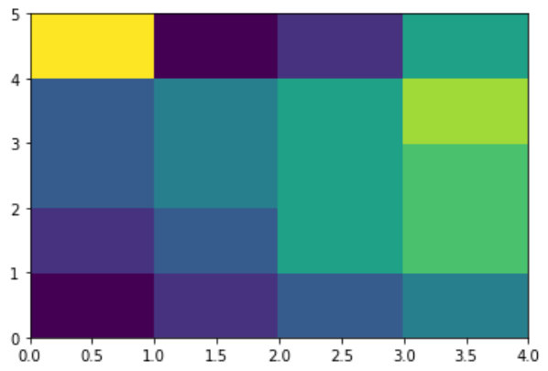

Bubble chart
A bubble chart is like a scatter chart that always displays two major value axes: one set of numerical data along the horizontal axis and another set of numerical values along the vertical axis. It is widely used to depict correlations between three or more numerical variables. The color of the bubble or its movement in animation can sometimes symbolize additional dimensions. By adding a third numeric column that determines the size of the data.
When to use Bubble Chart:
Whenever we want to create a relationship between two numeric values with their size.
The third metric (size) helps in determining the value differences of various intersections.
It also helps in analyzing financial data.
To display data with quadrants.
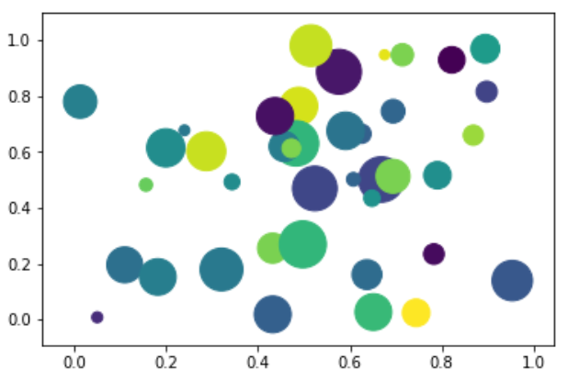
Density Chart
Density Plot is a type of data visualization tool. It is a variation of the histogram that uses ‘kernel smoothing’ while plotting the values. It is a continuous and smooth version of a histogram inferred from a data. Density plots uses Kernel Density Estimation (so they are also known as Kernel density estimation plots or KDE) which is a probability density function. The region of plot with a higher peak is the region with maximum data points residing between those values. Density plots can be made using pandas, seaborn, etc.
Syntax: pandas. DataFrame.plot. density | pandas.DataFrame.plot.kde
where pandas -> the dataset of the type ‘pandas dataframe’
Dataframe -> the column for which the density plot is to be drawn
plot -> keyword directing to draw a plot/graph for the given column
density -> for plotting a density graph
kde -> to plot a density graph using the Kernel Density Estimation function
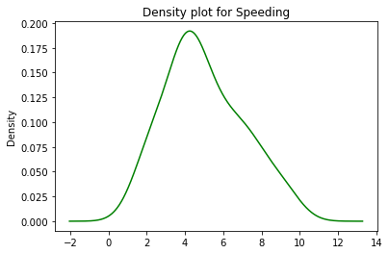
Scatterplot
Scatter plot is one of the most important data visualization techniques and it is considered one of the Seven Basic Tools of Quality. A scatter plot is used to plot the relationship between two variables, on a two-dimensional graph that is known as Cartesian Plane on mathematical grounds. It is generally used to plot the relationship between one independent variable and one dependent variable, where an independent variable is plotted on the x-axis and a dependent variable is plotted on the y-axis so that you can visualize the effect of the independent variable on the dependent variable. These plots are known as Scatter Plot Graph or Scatter Diagram.
Matplotlib stands as an extensive library in Python, offering the capability to generate static, animated, and interactive visualizations. The Matplotlib.pyplot.scatter() in Python extends to creating diverse plots such as scatter plots, bar charts, pie charts, line plots, histograms, 3-D plots, and more.
Syntax: matplotlib. pyplot. scatter (x_axis_data, y_axis_data, s=None, c=None, marker=None, cmap=None, vmin=None, vmax=None, alpha=None, linewidths=None, edgecolors=None)
Parameters:
x_axis_data: An array containing data for the x-axis.matplotlib
s: Marker size, which can be a scalar or an array of size equal to the size of x or y.
c: Color of the sequence of colors for markers.
marker: Marker style.
cmap: Colormap name.
linewidths: Width of the marker border.
edgecolor: Marker border color.
alpha: Blending value, ranging between 0 (transparent) and 1 (opaque).
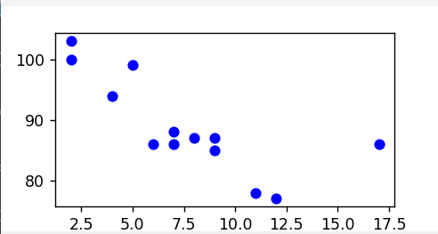

Histogram
A Histogram represents data provided in the form of some groups. It is an accurate method for the graphical representation of numerical data distribution. It is a type of bar plot where the X-axis represents the bin ranges while the Y-axis gives information about frequency. In Matplotlib, we use the hist() function to create histograms.The hist() function will use an array of numbers to create a histogram, the array is sent into the function as an argument. For simplicity we use NumPy to randomly generate an array with 250 values, where the values will concentrate around 170, and the standard deviation is 10.
Parameters: This method accept the following parameters that are described below:
x : This parameter are the sequence of data.
bins : This parameter is an optional parameter and it contains the integer or sequence or string.
range : This parameter is an optional parameter and it the lower and upper range of the bins.
density : This parameter is an optional parameter and it contains the boolean values.
weights : This parameter is an optional parameter and it is an array of weights, of the same shape as x.
bottom : This parameter is the location of the bottom baseline of each bin.
histtype : This parameter is an optional parameter and it is used to draw type of histogram. {‘bar’, ‘barstacked’, ‘step’, ‘stepfilled’}
align : This parameter is an optional parameter and it controls how the histogram is plotted. {‘left’, ‘mid’, ‘right’}
rwidth : This parameter is an optional parameter and it is a relative width of the bars as a fraction of the bin width
log : This parameter is an optional parameter and it is used to set histogram axis to a log scale
color : This parameter is an optional parameter and it is a color spec or sequence of color specs, one per dataset.
label : This parameter is an optional parameter and it is a string, or sequence of strings to match multiple datasets.
normed : This parameter is an optional parameter and it contains the boolean values.It uses the density keyword argument instead.
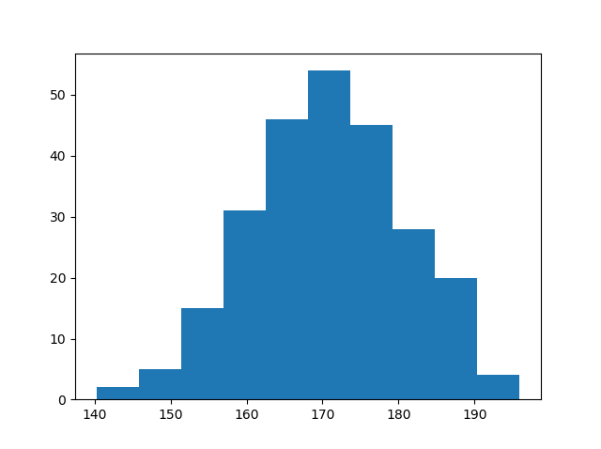
Quartile Chart
When the quantiles of two variables are plotted against each other, then the plot obtained is known as quantile – quantile plot or qqplot. This plot provides a summary of whether the distributions of two variables are similar or not with respect to the locations.

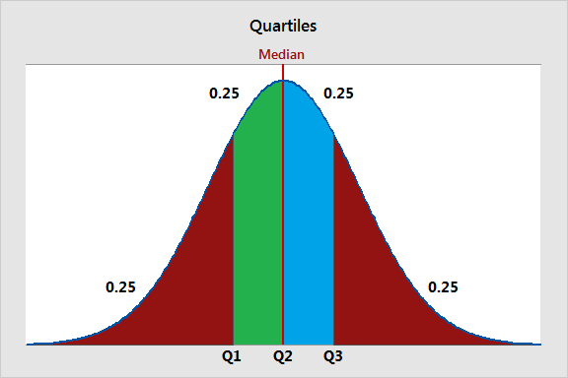
Pie Chart
Pie Chart is a circular statistical plot that can display only one series of data. The area of the chart is the total percentage of the given data. Pie charts are commonly used in business presentations like sales, operations, survey results, resources, etc. as they provide a quick summary.
Matplotlib API has pie() function in its pyplot module which create a pie chart representing the data in an array.
Syntax: matplotlib.pyplot.pie (data, explode=None, labels=None, colors=None, autopct=None, shadow=False)
Parameters:
data represents the array of data values to be plotted, the fractional area of each slice is represented by data/sum(data). If sum(data)<1, then the data values return the fractional area directly, thus resulting pie will have empty wedge of size 1-sum(data).
labels is a list of sequence of strings which sets the label of each wedge.
color attribute is used to provide color to the wedges.
autopct is a string used to label the wedge with their numerical value.
shadow is used to create shadow of wedge.
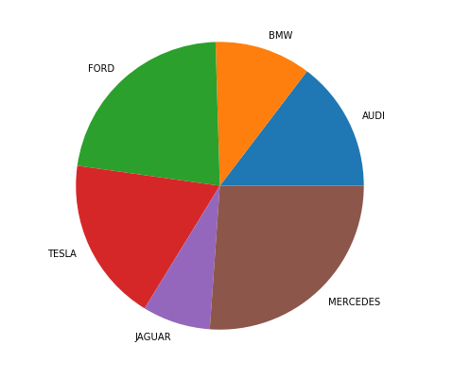
Bar Chart
A bar plot or bar chart is a graph that represents the category of data with rectangular bars with lengths and heights that is proportional to the values which they represent. The bar plots can be plotted horizontally or vertically. A bar chart describes the comparisons between the discrete categories. One of the axis of the plot represents the specific categories being compared, while the other axis represents the measured values corresponding to those categories.
The matplotlib API in Python provides the bar() function which can be used in MATLAB style use or as an object-oriented API. The syntax of the bar() function to be used with the axes is as follows:-
plt.bar(x, height, width, bottom, align)
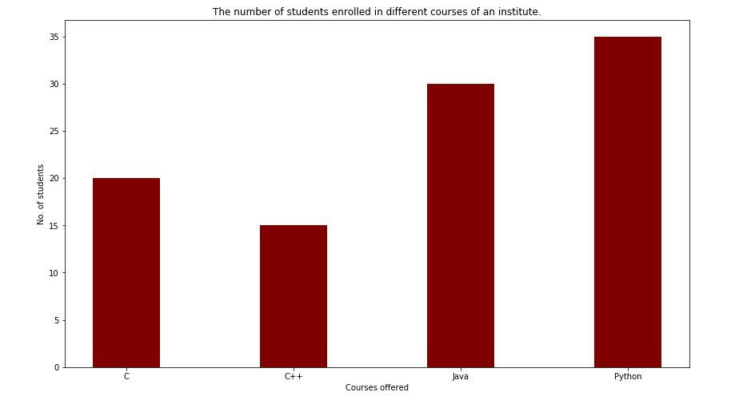
Boxplot
A Box Plot is also known as Whisker plot is created to display the summary of the set of data values having properties like minimum, first quartile, median, third quartile and maximum. In the box plot, a box is created from the first quartile to the third quartile, a vertical line is also there which goes through the box at the median. Here x-axis denotes the data to be plotted while the y-axis shows the frequency distribution.
The matplotlib.pyplot module of matplotlib library provides boxplot() function with the help of which we can create box plots.
Syntax:
matplotlib.pyplot.boxplot(data, notch=None, vert=None, patch_artist=None, widths=None)
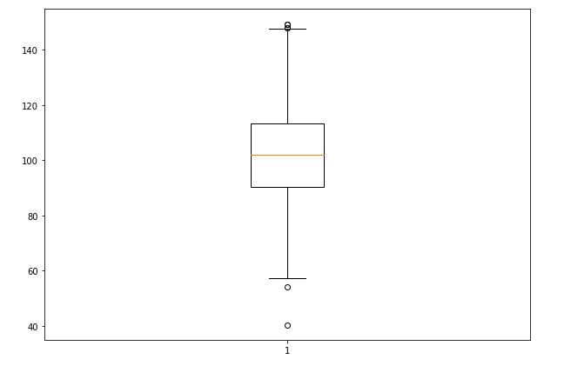
Area Chart
An area chart is really similar to a line chart, except that the area between the x axis and the line is filled in with color or shading. It represents the evolution of a numeric variable.
Parameters
data_frame: This argument needs to be passed for column names (and not keyword names) to be used. Array-like and dict are transformed internally to a pandas DataFrame.
x, y: Either a name of a column in data_frame, or a pandas Series or array_like object. Values from this column or array_like are used to position marks along the x and y axis in cartesian coordinates.
color: Either a name of a column in data_frame, or a pandas Series or array_like object. Values from this column or array_like are used to assign color to marks.
